Section I: Scenario Demographics

Scenario Title: | Pulmonary Embolism
Date of Development: | 07/04/2016 (DD/MM/YYYY)
Target Learning Group: | Juniors (PGY 1 – 2) Seniors (PGY ≥ 3) All Groups

Section II: Scenario Developers

Scenario Developer(s): | Donika Orlich
Affiliations/Institution(s): | McMaster University
Contact E-mail (optional): | Donika.orlich@medportal.ca

Section III: Curriculum Integration

Learning Goals & Objectives
Educational Goal: | Expose learners to PEA arrest secondary to pulmonary embolism with complications secondary to thrombolysis
CRM Objectives: | - Demonstrates situational awareness by avoiding fixation error and reassessing the situation constantly  - Demonstrates leadership skills by employing prompt decision making and maintaining control during crisis
Medical Objectives: | - Recognizes the need for thrombolysis in pulmonary embolism with arrest  - Maintains and works through broad differential diagnosis of persistent hypotension  - Recognizes bleeding from thrombolysis as a cause for persistent hypotension

Case Summary: Brief Summary of Case Progression and Major Events
A 63-year-old female is in the Emergency Department awaiting internal medicine consultation for a diagnosed pulmonary embolism. She suddenly becomes very short of breath while walking to the bathroom and the team is called to assess. The patent will then arrest, necessitating thrombolysis. After ROSC, she will stabilize briefly but then develop increasing vasopressor requirements. The team will need to work through the shock differential diagnosis and recognize free fluid in the abdomen as a complication of thrombolysis requiring surgical consultation and transfusion.

Facilitators Required to Run Session
Instructors (Faculty): 1-2 (one to observe, one to run mannequin if no sim tech)
Confederate nurse: 1 (to assist at bedside, cue to WOB)
Sim techs: 1

Section IV: Scenario Script

A. Scenario Cast & Realism
Patient: | Computerized Mannequin |  |  |  |  | Realism:  Select most important dimension(s) |  |  | Conceptual
 | Mannequin |  |  |  |  |  |  |  | Physical
 | Standardized Patient |  |  |  |  |  |  |  | Emotional/Experiential
 | Hybrid |  |  |  |  |  |  |  | Other:
 | Task Trainer |  |  |  |  |  |  |  | N/A
Confederates | Brief Description of Role
Nurse | To assist at bedside and cue learners to patient’s status.
B. Required Monitors
EKG Leads/Wires |  |  | Temperature Probe |  |  |  | Central Venous Line
NIBP Cuff |  |  | Defibrillator Pads |  |  |  | Capnography
Pulse Oximeter |  |  | Arterial Line |  |  |  | Other:
C. Required Equipment
Gloves |  |  | Nasal Prongs |  |  |  | Scalpel
Stethoscope |  |  | Venturi Mask |  |  |  | Tube Thoracostomy Kit
Defibrillator |  |  | Non-Rebreather Mask |  |  |  | Cricothyroidotomy Kit
IV Bags/Lines |  |  | Bag Valve Mask |  |  |  | Thoracotomy Kit
IV Push Medications |  |  | Laryngoscope |  |  |  | Central Line Kit
PO Tabs |  |  | Video Assisted Laryngoscope |  |  |  | Arterial Line Kit
Blood Products |  |  | ET Tubes |  |  |  | Other: BiPAP
Intraosseous Set-up |  |  | LMA |  |  |  | Other:
D. Moulage
Female wig. IV in situ at onset of case.

E. Approximate Timing
Set-Up: |  | 5min |  | Scenario: | 15 min |  |  | Debriefing: |  | 30 min

Section V: Patient Data and Baseline State

A. Clinical Vignette: To Read Aloud at Beginning of Case
You are called urgently to the bedside of a patient who is in the Emergency Department awaiting medicine consultation. Your colleague saw her earlier. She is 63 years old and has a CT-confirmed pulmonary embolism. She had presented with SOBOE in the context of a recent hysterectomy 4 weeks ago. She has been stable in the ED until she got up to go to the bathroom and suddenly developed severe SOB.
B. Patient Profile and History
Patient Name: Dawn Hathaway |  |  |  |  |  | Age: 63 |  |  |  |  |  |  |  | Weight: 55kg
Gender: M F |  |  |  |  |  | Code Status: FULL
Chief Complaint: Increased SOB x2 days
History of Presenting Illness: Increased SOB for past 2 days, especially with walking. Suddenly severe SOB while up to the washroom in the ED. Has not yet been this bad.
Past Medical History: |  | Recent hysterectomy for AUB |  |  |  |  | Medications: |  |  |  |  | Januvia
 |  | DM 2 |  |  |  |  |  |  |  |  |  | Given 15mg rivaroxaban in ED after diagnosis
 |  | Breast Cx (sx + chemo 3 yrs ago)
 |  | DVT (3 yrs ago)
Allergies: None
Social History: Lives with husband. Smokes ½ ppd. 2 EtOH per day. No other drugs.
Review of Systems: |  | CNS: |  |  | Nil
 |  | HEENT: |  |  | Nil
 |  | CVS: |  |  | No chest pain.
 |  | RESP: |  |  | As above. No recent cough/fever
 |  | GI: |  |  | Nil
 |  | GU: |  |  | Nil
 |  | MSK: |  |  | Nil |  |  |  |  |  |  |  | INT: |  | Nil
C. Baseline Simulator State and Physical Exam
No Monitor Display |  |  |  | Monitor On, no data displayed |  |  |  |  |  |  | Monitor on Standard Display
HR: 144/min |  |  | BP: 131/73 |  |  |  |  | RR: 26/min |  |  |  |  |  |  | O₂SAT: 88% RA
Rhythm: sinus |  |  | T: 37.1ºC |  |  |  |  | Glucose: 12 mmol/L |  |  |  |  |  |  | GCS: 15 (E4 V5 M6)
General Status: Speaking 1-2 word sentences. Obviously in distress.
CNS: | Normal exam
HEENT: | Normal exam
CVS: | Normal S1, S2. No murmurs. No pedal edema.
RESP: | Tachypneic with accessory muscle use. No adventitious sounds.
ABDO: | Soft. Non-tender.
GU: | Normal exam.
MSK: | Nil. No calf swelling/tenderness. |  |  |  |  |  |  |  | SKIN: | Nil

Section VI: Scenario Progression
Scenario States, Modifiers and Triggers
Patient State | Patient Status | Learner Actions, Modifiers & Triggers to Move to Next State
1. Baseline State  Rhythm: sinus  HR: 144/min  BP: 131/73  RR: 26/min  O₂SAT: 88% RA  T: 37.1ºC | Clear respiratory distress. Speaking 1-2 word sentences with obvious accessory muscle use. (RN to cue re: same) | Learner Actions  - O2, monitors  - Brief history and physical  - Stat portable CXR  - ECG  - 1L IV NS bolus  - ± Bedside US (for lung sliding, R heart strain)  - BiPAP for increased WOB  - Prepare for intubation  - Consider thrombolysis | Modifiers  Changes to patient condition based on learner action  - NRB O2 97%  - 1L NS bolus HR 125  - RN to give prior lab/CT results to team for review  Triggers  For progression to next state  - All actions complete or 5 min into case 2. Arrest
2. Arrest  Rhythm: Junctional  HR: 35 (no pulse)  BP: 0  RR: BMV rate (10-12)  O₂SAT: ?  EtCO2: 10 (15-20 if high quality CPR) | Patient begins state saying “I don’t feel very well” then unresponsive and pulseless | Learner Actions  - Recognize PEA arrest and begin CPR  - Epi 1mg q3-5min  - Thrombolysis (alteplase 15mg iv bolus then 85mg over 2h vs tenecteplase 50mg IV bolus)  - Intubation  - IV NS fluid bolus | Modifiers  - Three cycles of CPR with no lytics considered RN to prompt “would you like me to draw up some TNK?”  Triggers  - One cycle of CPR after thrombolytics given 3. ROSC
3. ROSC  Rhythm: sinus  HR: 110/min  BP: 75/35  RR: 12/min (vented)  O₂SAT: 95%  EtCO2: 40 | Patient non-responsive, but has a pulse. | Learner Actions  - Post-intubation CXR  - Start low-dose sedation  - Start vasopressor  - ± Cooling  - Consult thrombosis & ICU | Modifiers  - Vasopressor started (at any dose) BP to 96/55  Triggers  - All actions complete or 4 min 4. Worsening Hypotension
4. Worsening Hypotension  Rhythm: NSR  HR: 120 /min  BP: 70/40  RR: 12/min (vented)  O₂SAT: 93% | Patient intubated and sedated.  Abdomen firm and distended. | Learner Actions  - Repeat physical exam  - Assess vent pressures (normal)  - Increase pressor ± add 2nd  - IV NS bolus  - Repeat CXR, ECG  - Send repeat labs: VBG, lactate, CBC, etc.  - Bedside US (normal lung sliding, FF abdomen, no PCE)  - Transfuse pRBC once identify abdominal FF  - Activate massive transfusion protocol  - General Sx consult | Modifiers  - 2L NS or 2uPRBC BP 80/45, HR 100  - If no consideration of bleeding 4 min into state RN to prompt “Want me to send a repeat hemoglobin?”  END CASE PRN with GEN SURG OR ICU ARRIVAL

Section VII: Supporting Documents, Laboratory Results, & Multimedia

Laboratory Results
Na: 140 | K: 4 |  |  | Cl: 105 |  | HCO₃: 25 |  | BUN: 5 |  | Cr: 80 |  |  | Glu: 5.5
Troponin I: 70 |  |  | D-dimer: >4,000
VBG |  | pH: 7.38 |  |  | PCO₂: 40 |  | PO₂: 78 |  | HCO₃: 25 |  |  | Lactate: 1.8
WBC: 12 |  |  | Hg: 125 |  |  |  | Hct: 0.4 |  |  |  | Plt: 300

Images (ECGs, CXRs, etc.)
CXR: normal  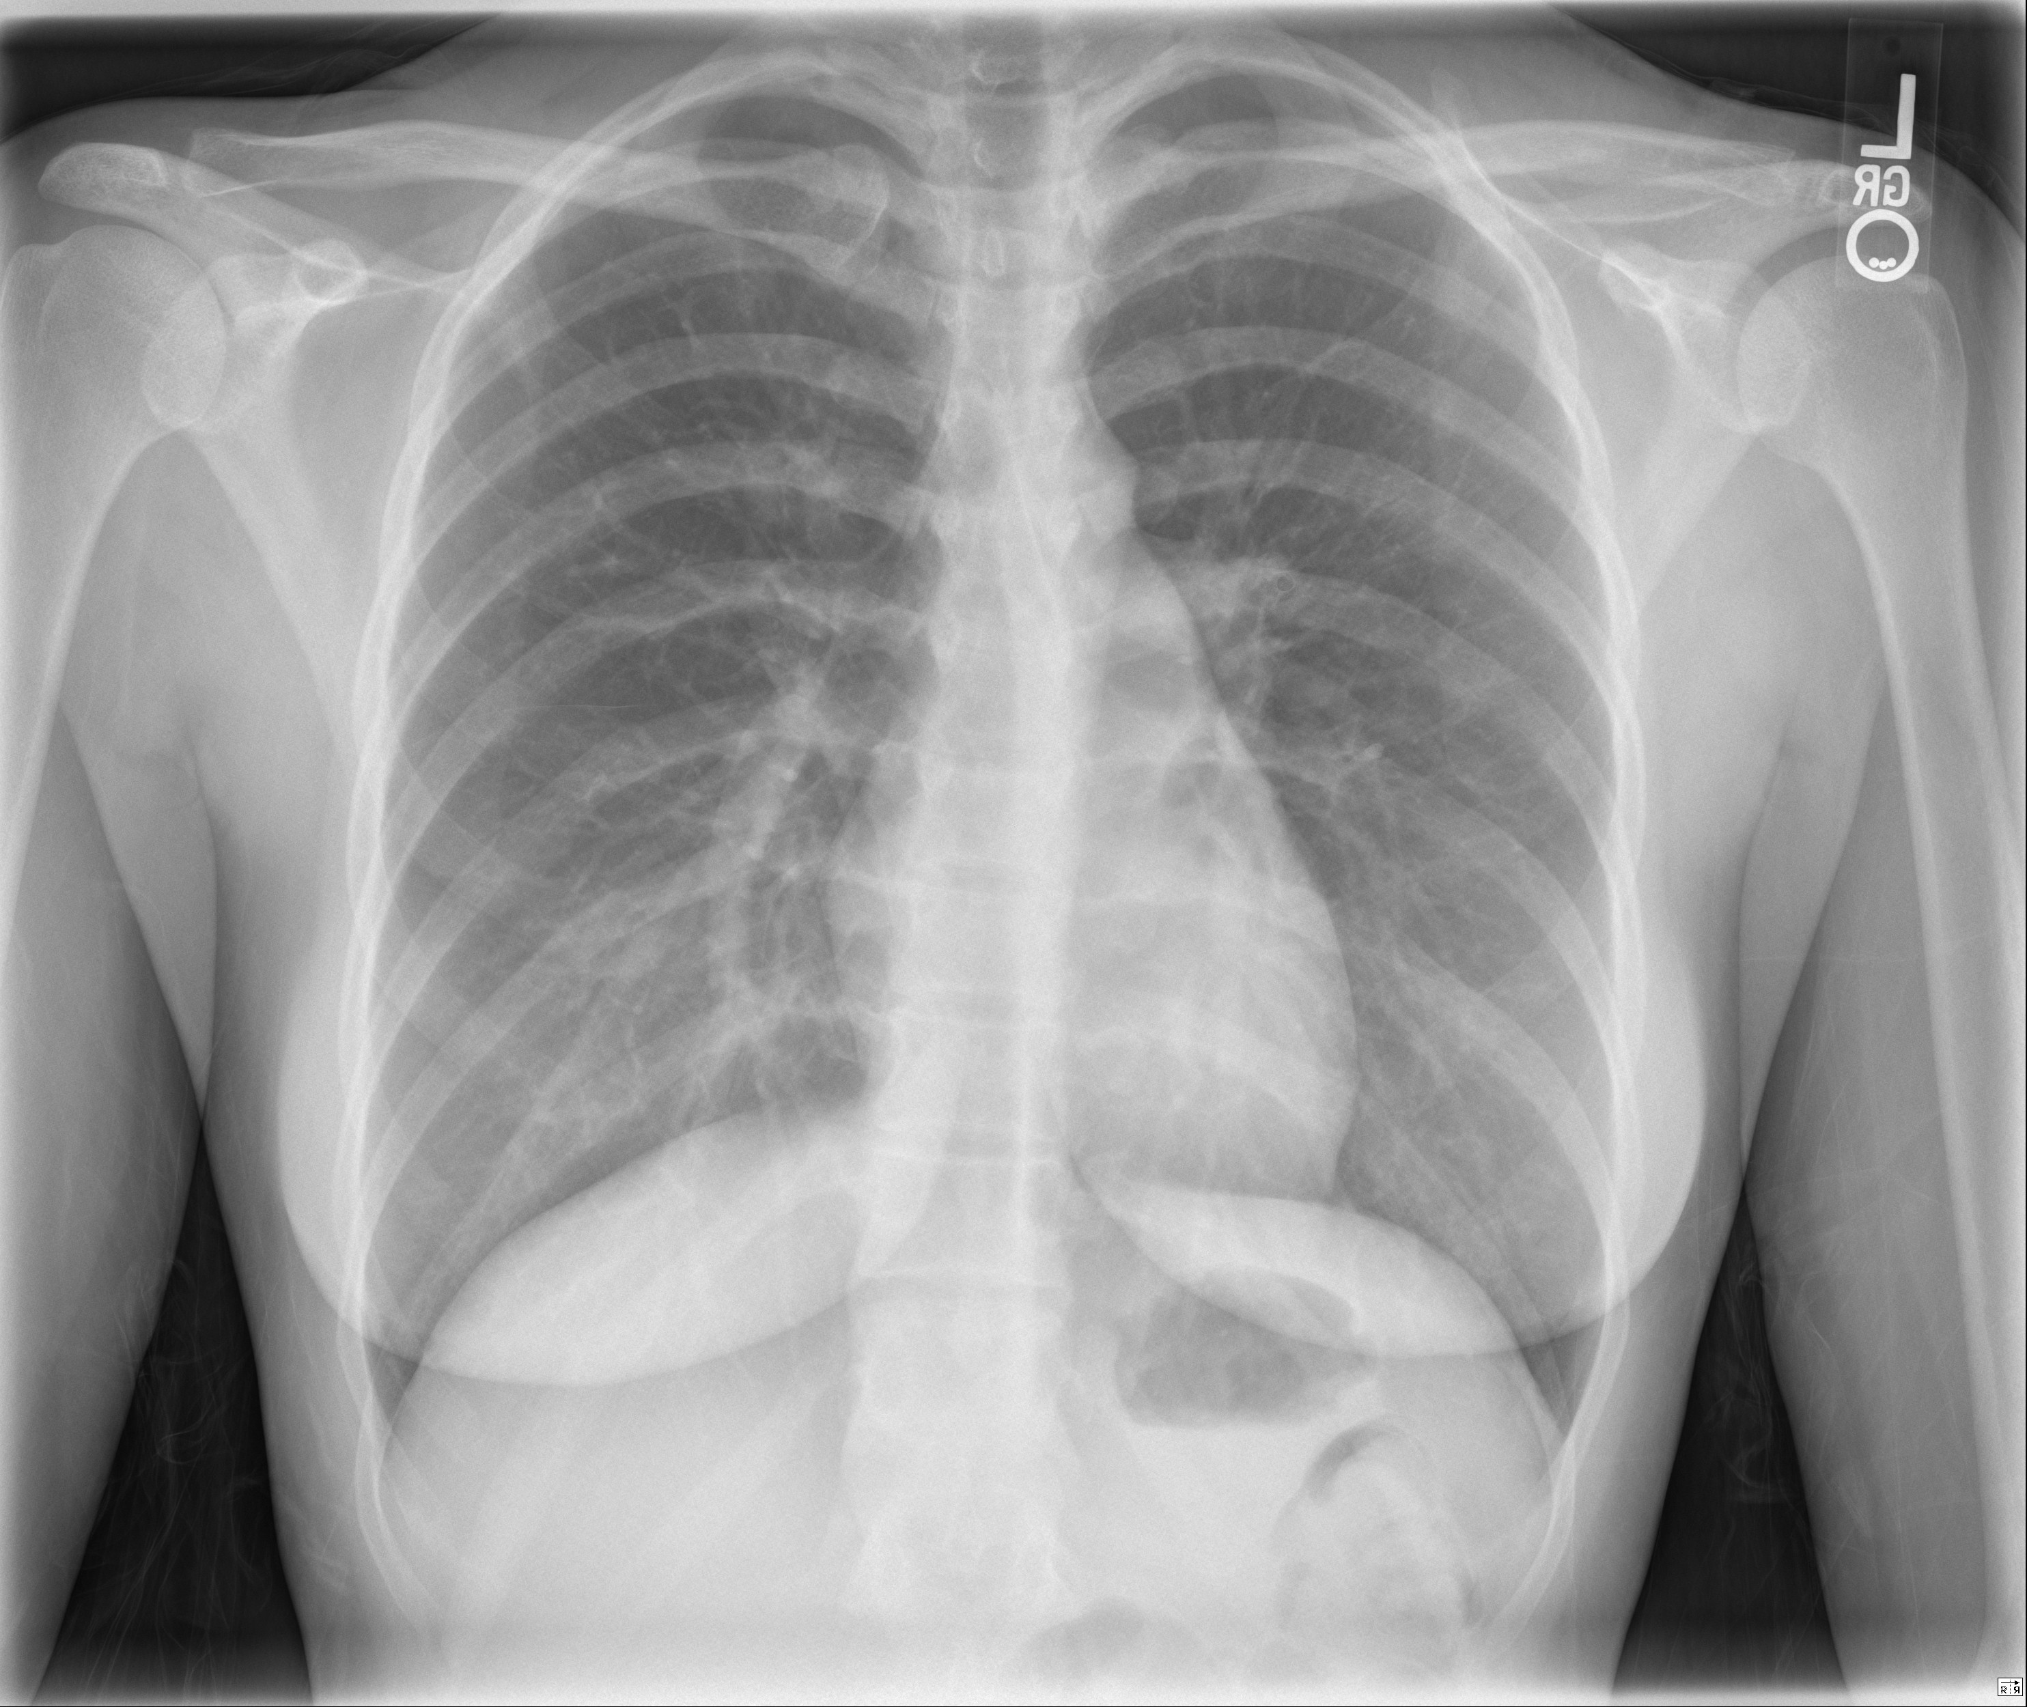  CXR source: https://radiopaedia.org/cases/normal-chest-radiograph-female-1 | CXR: post-intubation  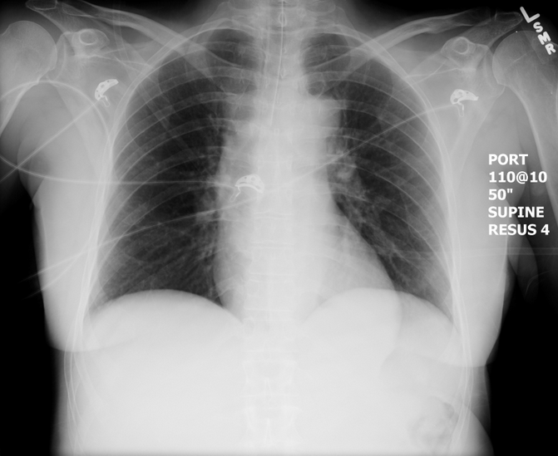  CXR source: https://emcow.files.wordpress.com/2012/11/normal-intubation2.jpg
ECG: RBBB, R-axis deviation, TWI V1-V4  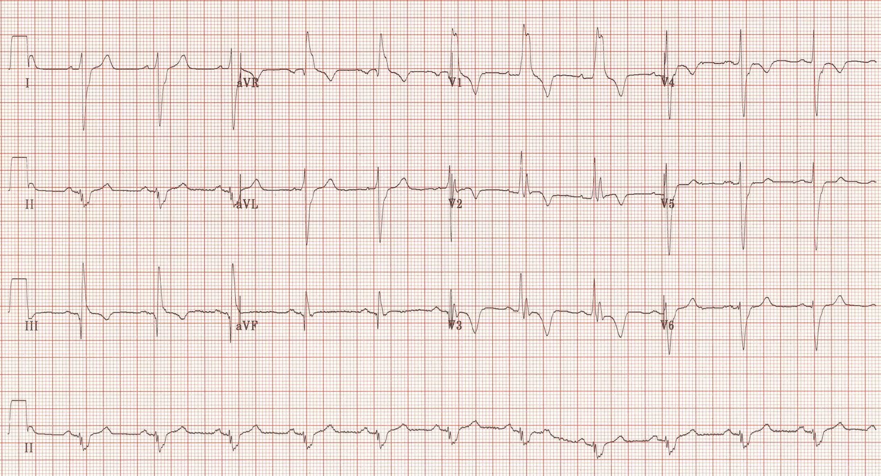  ECG source: https://lifeinthefastlane.com/ecg-library/pulmonary-embolism/ | Initial Bedside US (state 1):  - No PCE, dilated RV, + McConnel’s sign  - Normal lungs  Repeat Bedside US (state 4):  - Pericardial Unchanged  - Abdominal free fluid  - Normal lungs
Section VIII: Debriefing Guide

General Debriefing Plan
Individual | Group | With Video | Without Video
Objectives
Educational Goal: | Expose learners to PEA arrest secondary to pulmonary embolism with complications secondary to thrombolysis
CRM Objectives: | - Demonstrates situational awareness by avoiding fixation error and reassessing the situation constantly  - Demonstrates leadership skills by employing prompt decision making and maintaining control during crisis
Medical Objectives: | - Recognizes the need for thrombolysis in pulmonary embolism with arrest  - Maintains and works through broad differential diagnosis of persistent hypotension  - Recognizes bleeding from thrombolysis as a cause for persistent hypotension
Sample Questions for Debriefing
- What was your rationale for thrombolysis in this patient? When did you first consider thrombolysis? What about your decision to anticoagulate?
- What was your approach to new hypotension following ROSC in this patient? Do you feel that you considered all possible causes of shock in this patient?
- What are the relative and absolute contra-indications to thrombolysis? What relative contra-indication did this patient have?
- What choices of thrombolytic are available in the context of arrest? What are the indications for thrombolysis when a patient has massive PE without arrest?
Key Moments
- Recognition of PE as likely cause of sudden worsening
- Decision to administer thrombolysis
- Recognition of bleeding as possible complication of thrombolysis and cause of hypotension

